Assignment 2

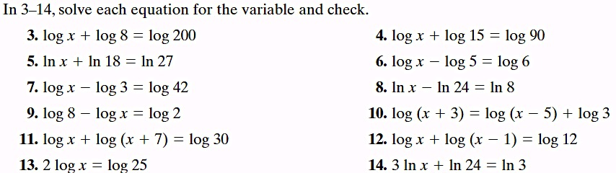

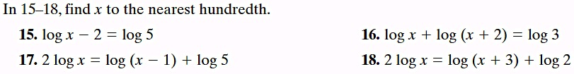

Name: Date:
Assignment 2

